There are three categories of paper that can be used as feedstocks for making recycled paper: mill broke, pre-consumer waste, and [post-consumer waste](http://en.wikipedia.org/wiki/Post-consumer_waste).[[1]](http://en.wikipedia.org/wiki/Paper_recycling#cite_note-debunking-1) *Mill broke* is paper trimmings and other paper scrap from the manufacture of paper, and is recycled internally in a [paper mill](http://en.wikipedia.org/wiki/Paper_mill). *Pre-consumer waste* is material which left the paper mill but was discarded before it was ready for consumer use. *Post-consumer* waste is material discarded after consumer use, such as old corrugated containers (OCC), old magazines, and newspapers.[[1]](http://en.wikipedia.org/wiki/Paper_recycling#cite_note-debunking-1)Paper suitable for recycling is called "scrap paper". Of the three methods we have made our project based on post consumer waste.

The share of ink in a wastepaper stock is up to about 2% of the total weight

Rationale for recycling[[edit](http://en.wikipedia.org/w/index.php?title=Paper_recycling&action=edit&section=2)]

Industrialized paper making has an effect on the environment both upstream (where raw materials are acquired and processed) and downstream (waste-disposal impacts).[[4]](http://en.wikipedia.org/wiki/Paper_recycling#cite_note-4)

Today, 40% of paper pulp is created from wood (in most modern mills only 9-16% of pulp is made from pulp logs; the rest comes from waste wood that was traditionally burnt). Paper production accounts for about 35% of felled trees,[[5]](http://en.wikipedia.org/wiki/Paper_recycling#cite_note-chase-5) and represents 1.2% of the world's total economic output.[[6]](http://en.wikipedia.org/wiki/Paper_recycling#cite_note-6) Recycling one ton of [newsprint](http://en.wikipedia.org/wiki/Newsprint) saves about 1 ton of wood while recycling 1 ton of printing or copier paper saves slightly more than 2 tons of wood.[[7]](http://en.wikipedia.org/wiki/Paper_recycling#cite_note-7) This is because [kraft pulping](http://en.wikipedia.org/wiki/Kraft_process) requires twice as much wood since it removes [lignin](http://en.wikipedia.org/wiki/Lignin) to produce higher quality fibres than mechanical pulping processes. Relating tons of paper recycled to the number of trees not cut is meaningless, since tree size varies tremendously and is the major factor in how much paper can be made from how many trees.[[8]](http://en.wikipedia.org/wiki/Paper_recycling#cite_note-8) Trees raised specifically for pulp production account for 16% of world pulp production, old growth forests 9% and second- and third- and more generation forests account for the balance.[[5]](http://en.wikipedia.org/wiki/Paper_recycling#cite_note-chase-5) Most pulp mill operators practice [reforestation](http://en.wikipedia.org/wiki/Reforestation) to ensure a continuing supply of trees.[[*citation needed*](http://en.wikipedia.org/wiki/Wikipedia:Citation_needed)] The [Programme for the Endorsement of Forest Certification](http://en.wikipedia.org/wiki/Programme_for_the_Endorsement_of_Forest_Certification) (PEFC) and the [Forest Stewardship Council (FSC)](http://en.wikipedia.org/wiki/Forest_Stewardship_Council) certify paper made from trees harvested according to guidelines meant to ensure good forestry practices.[[9]](http://en.wikipedia.org/wiki/Paper_recycling#cite_note-9) It has been estimated that recycling half the world’s paper would avoid the harvesting of 20 million acres (81,000 km²) of forestland.[[10](http://en.wikipedia.org/wiki/Paper_recycling#cite_note-10)

### Energy[[edit](http://en.wikipedia.org/w/index.php?title=Paper_recycling&action=edit&section=3)]

|  |  |
| --- | --- |
|  |  |

Energy consumption is reduced by recycling,[[11]](http://en.wikipedia.org/wiki/Paper_recycling#cite_note-11) although there is debate concerning the actual energy savings realized. The [Energy Information Administration](http://en.wikipedia.org/wiki/Energy_Information_Administration) claims a 40% reduction in energy when paper is recycled versus paper made with unrecycled pulp,[[12]](http://en.wikipedia.org/wiki/Paper_recycling#cite_note-12) while the [Bureau of International Recycling](http://en.wikipedia.org/wiki/Bureau_of_International_Recycling) (BIR) claims a 64% reduction.[[13]](http://en.wikipedia.org/wiki/Paper_recycling#cite_note-BIR2-13) Some calculations show that recycling one ton of newspaper saves about 4,000 [kWh](http://en.wikipedia.org/wiki/Watt-hour) (14 [GJ](http://en.wikipedia.org/wiki/Joule)) of electricity, although this may be too high (see comments below on unrecycled pulp). This is enough electricity to power a 3-bedroom European house for an entire year, or enough energy to heat and air-condition the average North American home for almost six months.[[14]](http://en.wikipedia.org/wiki/Paper_recycling#cite_note-14) Recycling paper to make pulp actually consumes more fossil fuels than making new pulp via the [kraft process](http://en.wikipedia.org/wiki/Kraft_process); these mills generate most of their energy from burning waste wood (bark, roots, sawmill waste) and byproduct lignin (black liquor).[[15]](http://en.wikipedia.org/wiki/Paper_recycling#cite_note-15) Pulp mills producing new mechanical pulp use large amounts of energy; a very rough estimate of the electrical energy needed is 10 gigajoules per [tonne](http://en.wikipedia.org/wiki/Tonne) of pulp (2500 kW·h per [short ton](http://en.wikipedia.org/wiki/Short_ton)).[[16]](http://en.wikipedia.org/wiki/Paper_recycling#cite_note-bier-16)

[hydrogen peroxide](http://en.wikipedia.org/wiki/Hydrogen_peroxide) and [sodium hydrosulfite](http://en.wikipedia.org/wiki/Sodium_hydrosulfite) are the most common bleaching agents

* Recycled paper produces 73% less air pollution than if it was made from raw materials.
* 12.5 million tonnes of paper and cardboard are used annually in the UK.
* The average person in the UK gets through 38kg of newspapers per year.
* It takes 24 trees to make 1 ton of newspaper.
* Reduces greenhouse gas emissions that can contribute to climate change by avoiding methane emissions and reducing energy required for a number of paper products.
* Extends the fiber supply and contributes to [carbon sequestration](http://www.epa.gov/osw/conserve/materials/paper/resources/glossary.htm#carbon).
* Saves considerable landfill space.
* Reduces energy and water consumption.
* Decreases the need for disposal (i.e., landfill or incineration which decreases the amount of CO2 produced).

Source: 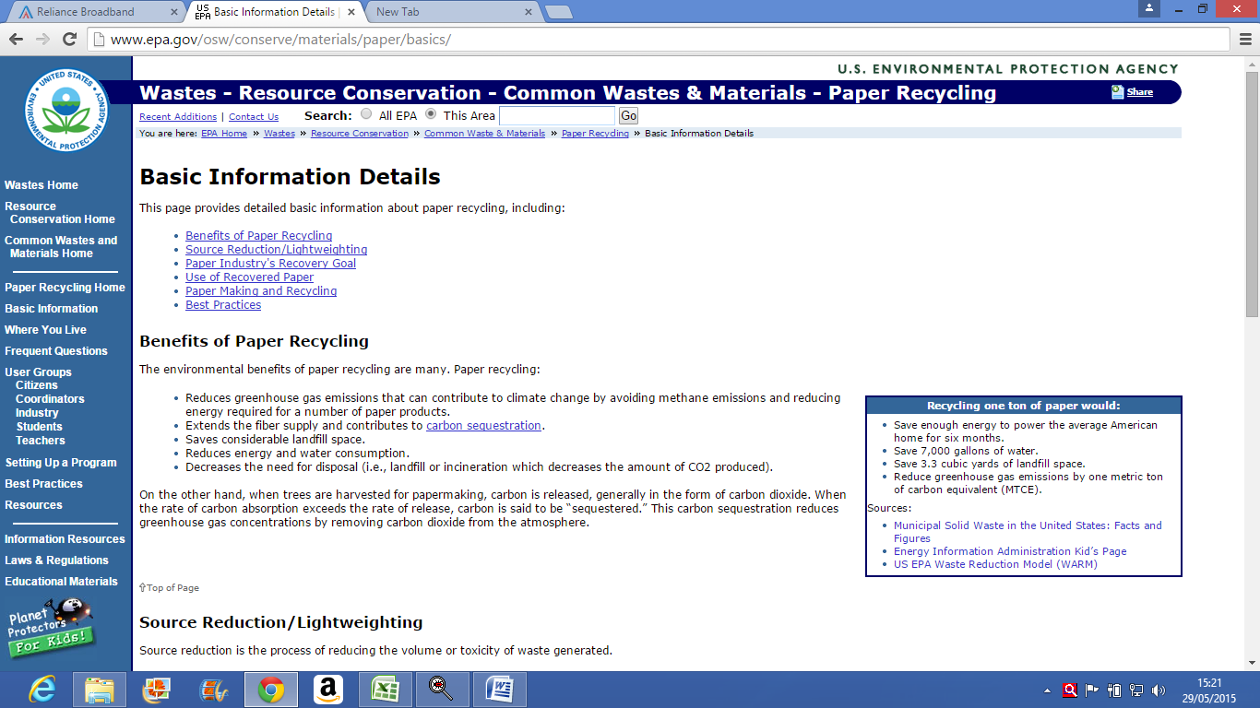

Paper, which includes everything from packaging to mail, makes up the largest percentage of the municipal solid waste stream at 33 percent. It’s also one of the most recovered materials, as recycling opportunities are often readily available.

<http://www.bir.org/industry/paper/>